PARTICIPANTS NEEDED!  You may be eligible if you:  - Are between the ages of 18-65  - Have been diagnosed with schizophrenia  - Experience frequent auditory hallucinations resistant to medication  - Have been on the same medications and dosage for at least 4 weeks  You will be compensated for your time. Participants who complete the study will be paid $200 - $260 over 3-4 weeks. | 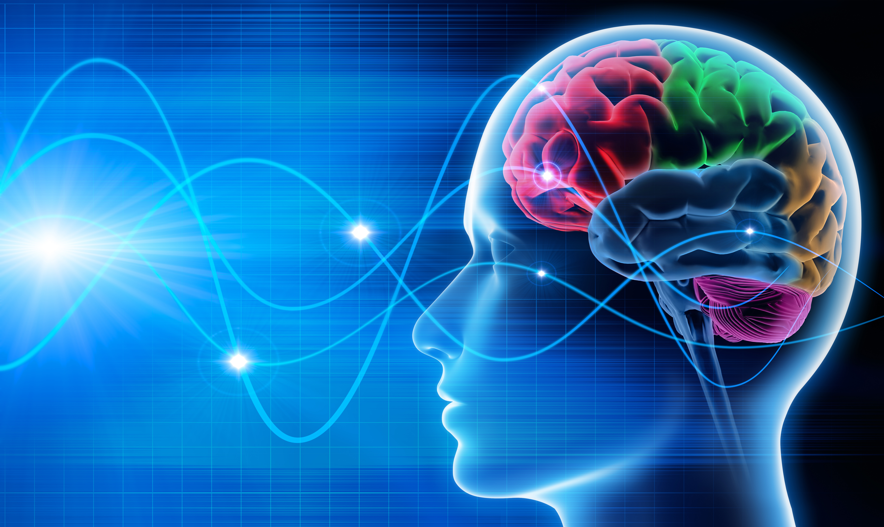  - Clinical Neuroelectrophysiology  - & Cognitive Research Laboratory  Transcranial direct current stimulation (tDCS) & Schizophrenia Study |  | 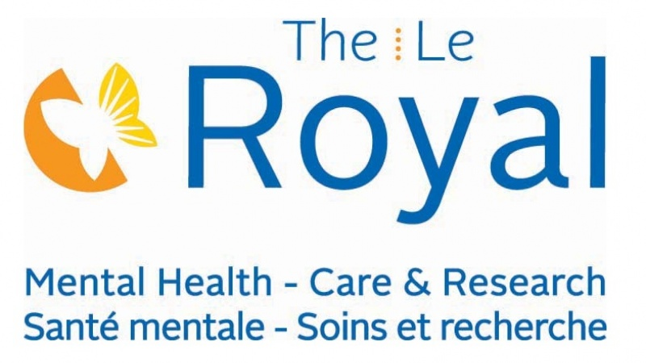  1145 Carling Avenue  Ottawa, ON K1Z 7K4  3rd Floor – Rm. 3128  If you are interested in participating, please contact us by email or phone!  Bronwen Schryver (Graduate Student)  Bronwen.Schryver@theroyal.ca  Phone: 613-722-6521 ext. 6094
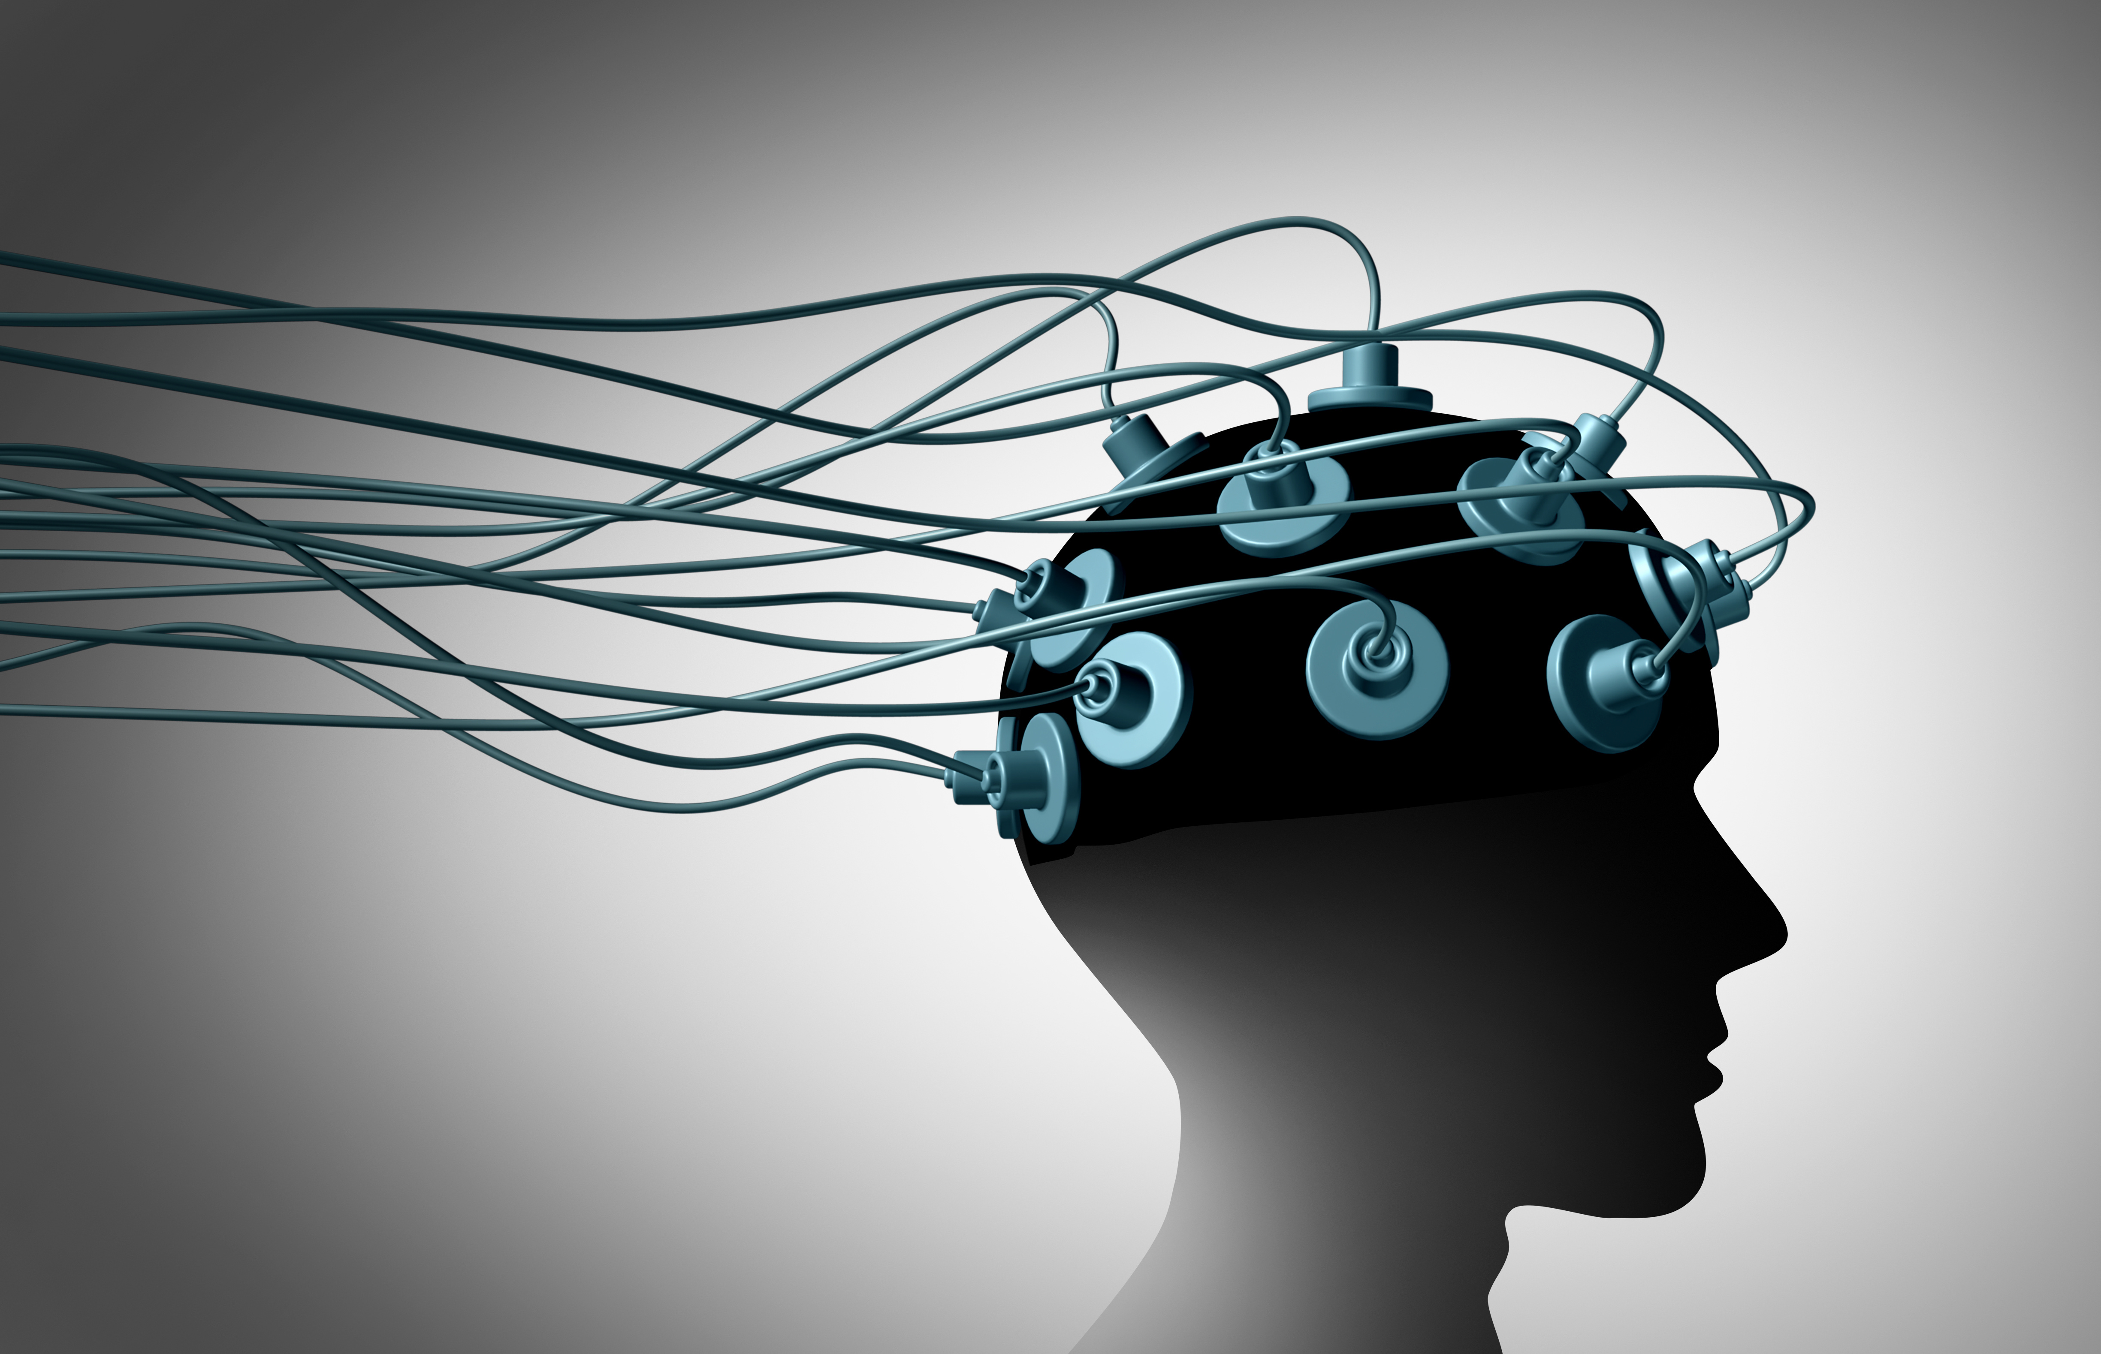  What is an EEG?  An electroencephalogram or EEG is a recording of a person’s brain electrical activity. By placing electrode sensors on the scalp, we are able to record this activity. EEG can be recorded while participants complete tasks to determine what happens to brain activity during tasks or EEG can be recorded during rest (no task).  Functional Magnetic Resonance Imaging (fMRI)  By having participants undergo an fMRI, we are able to look at brain activity by examining changes in blood flow.  Both EEG and fMRI procedures are non-invasive and have been proven to be safe with proper screening. | 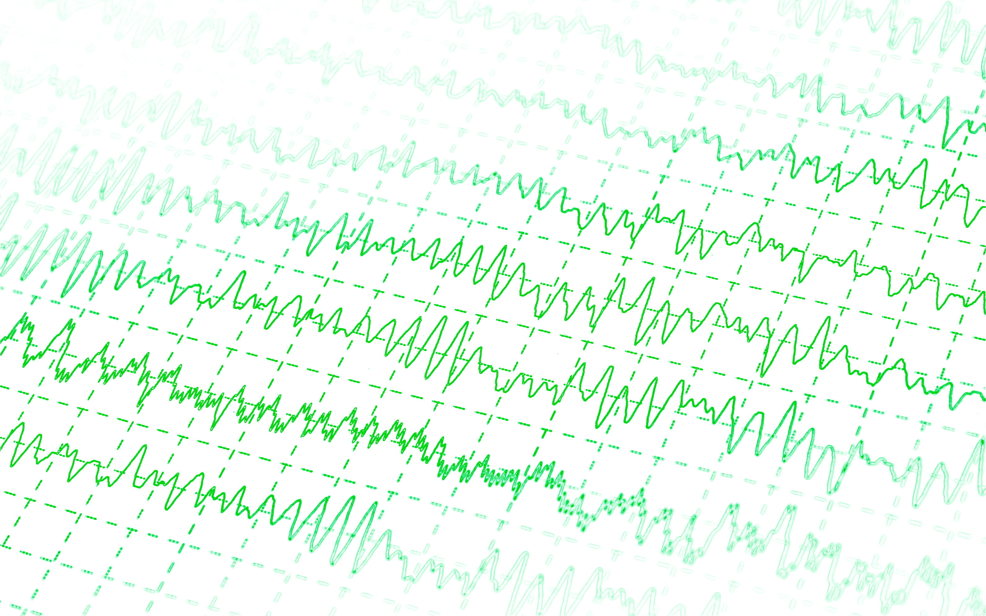  Transcranial Direct Current Stimulation (tDCS) is a safe & non-invasive brain stimulation technique that has been used in previous studies to treat symptoms of depression & cognitive impairment.  Your Role as a Participant  - Attend 2 appointments where you will be assessed for eligibility, fill out questionnaires, complete computerized cognitive tasks & undergo an EEG recording  - Undergo 10 tDCS sessions (2X/day for 5 days in a row; Monday-Friday)  - Attend 2 appointments after you have completed the 10 tDCS sessions to again fill out questionnaires, complete cognitive tasks & undergo an EEG recording.  - Undergo brain imaging before & after the course of tDCS. | Why Are We Doing This Study?  People with schizophrenia can have trouble with hallucinations that interfere with their daily life. These hallucinations can be resistant to treatment with medication. This study will assess whether a brain stimulation technique, transcranial direct current stimulation (tDCS), reduces hallucinations.  What Are We Doing?  We are recruiting participants to examine the effects of tDCS on hallucinations. tDCS involves placing small electrodes on the scalp to generate a very low current that may cause a minor tingling sensation. This current is thought to either boost or decrease your brain activity. This study will be measuring the usefulness of tDCS through questionnaires, computerized cognitive testing & brain activity measures.

