SEEKING PARTICIPANTS  You may be eligible if you are:  - Male OR Female  - 16-24 years old  - Currently experiencing symptoms of depression  - Not currently using antidepressants  - Not currently engaging in regular exercise  - No history of drug or alcohol abuse  - No additional medical or psychiatric complications | Clinical Neuroelectrophysiology & Cognitive Research Laboratory  1145 Carling Avenue  Ottawa, ON K1Z 7K4  Phone: 613-722-6521 ext. 6254  3rd Floor – Rm. 3128  If you are interested in participating, please contact us by email or phone:  Corrine Staff (Graduate Student)  Corrine.staff@theroyal.ca  Ayotola Ogunlana  (Research Assistant)  BrainLab@theroyal.ca  613-722-6521 ext. 6254  Royal Ottawa Mental Health Centre | YOUTH DEPRESSION & EXERCISE STUDY  - 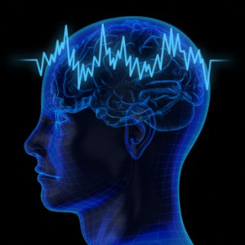  - Clinical Neuroelectrophysiology & Cognitive Research Laboratory  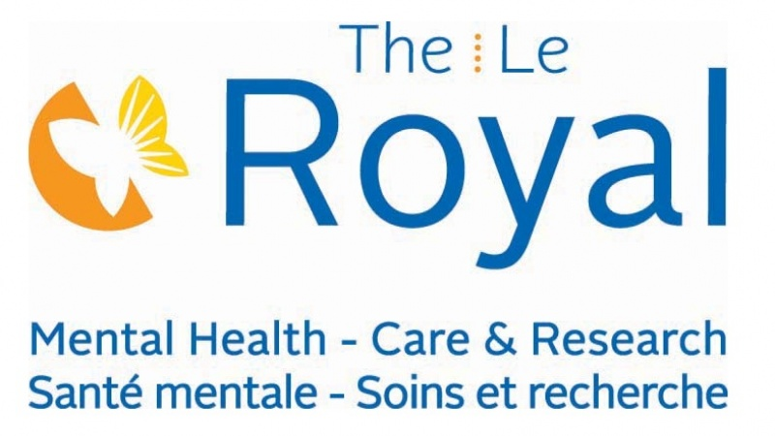

Study Details  Why are we doing this study?  Aerobic exercise (AE) has been shown to be an effective treatment option for some individuals experiencing symptoms of depression. However, it is not currently known what level of AE offers the greatest benefit, particularly for youth and young adults. We are also interested in better understanding the changes in brain structure and function that result from AE in depressed youth.  What does the study involve?  We are recruiting participants between 16 and 24 years old currently experiencing symptoms of depression to examine the effects of moderate vs. high intensity aerobic exercise on depression and cognition (ie. attention & memory). Participants will have their clinical symptoms, cognitive function, and brain activity assessed before and after undergoing a 12 week supervised exercise program. | Transitional-aged youth (TAY) are individuals between the age of 16-24 years old. Although TAY are at increased risk of developing MDD, current treatment options are limited.  Your Role:  Attend supervised exercise sessions at The Royal 3x per week, for 12 weeks. In addition:  - A baseline appointment where you will be assessed for eligibility, fill out questionnaires and complete a brief physical assessment.  - Two more testing sessions where you will complete computerized cognitive tasks while your brain activity is measured. The first session will use EEG, while the second session will use fMRI.  - These sessions will be completed once again to assess treatment outcomes at the end of your 12 week involvement. | 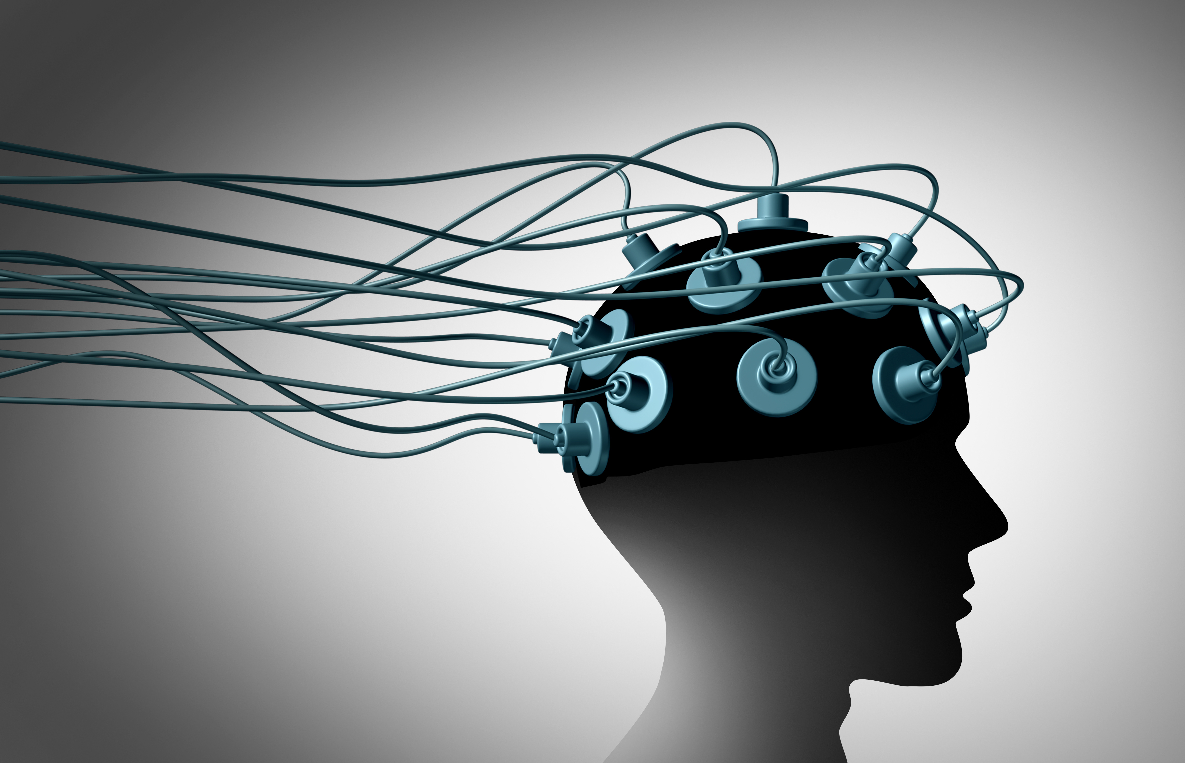  BRAIN IMAGING COMPONENTS  .  What is an EEG?  An electroencephalogram (EEG) is a recording of the electrical activity generated by a person’s brain. By placing electrode sensors on the scalp, we are able to record this activity.  What is fMRI?  Functional magnetic resonance imaging (fMRI) is another way to measure brain activity. By measuring changes, it allows us to assess which areas of the brain are most active before, during, and after completing a task.  Both EEG and fMRI procedures are non-invasive and have been proven to be safe.

